Enterprise application integration

Enterprise Application Integration (EAI) is defined as the use of software and computer systems architectural principles to integrate a set of enterprise computer applications

Enterprise Application Integration is an integration framework composed of a collection of technologies and services which form a middleware to enable integration of systems and applications across the enterprise.

In the words of the Gartner Group, EAI is the “unrestricted sharing of data and business processes among any connected application or data sources in the enterprise

simplify and automate business processes to the greatest extent possible, while at the same time avoiding having to make sweeping changes to the existing applications or data structures.

EAI is not just about sharing data between applications; it focuses on sharing both business data and business process
Enterprise application integration is a business need to make diverse applications in an enterprise including partner systems to communicate to each other to achieve a business objective in a seamless reliable fashion irrespective of platform and geographical location of these applications. It is a business need and business never dies it only evolves.

Provides following benefits.
- Opening up ways for the information to flow from one application to another,
- Letting applications to reach other sources of data outside themselves, and
- Allowing other programs to peer into the innards of formerly closed programs.
- Sharing data between divisions or even between separate corporations
- EAI focuses on the integration of both business-level processes and data, whereas the traditional middleware approach is data oriented.
- EAI includes the notion of reuse as well as distribution of business processes and data.
- EAI allows users who understand very little about the details of the applications to integrate the applications.
- Solution re-use, application decoupling and information standardization.
- Improving business process by enabling real time /near real time application integration
- Lowering TCO by re-use of services
- Decoupling applications minimizes impact on interfaces due to
  - application upgrade
  - application replacement
  - application re hosting.

- Function level integration rather than data level integration enables better use of application logic.
- A loosely coupled architecture providing higher flexibility to accommodate change.
- Ability to technical level monitoring of interfaces to enable IT to identify the impact and notify appropriate team.

Purposes of EAI
EAI can be used for different purposes:
- Data (information) Integration: Ensuring that information in multiple systems is kept consistent. This is also known as EII (Enterprise Information Integration).
- Vendor independence: Extracting business policies or rules from applications and implementing them in the EAI system, so that even if one of the business applications is replaced with a different vendor's application, the business rules do not have to be re-implemented.
- Common Facade: An EAI system could front-end a cluster of applications, providing a single consistent access interface to these applications and shielding users from having to learn to interact with different software packages

EAI comprises of message acceptance, transformation, translation, routing, message
delivery and business process management. Usually messages transportation is asynchronous but for a business need it can be synchronous as well.

EAI patterns

Integration patterns
There are two patterns that EAI systems implement:
Mediation
Here, the EAI system acts as the go-between or broker between (interface or communicating) multiple applications. Whenever an interesting event occurs in an application (e. g., new information created, new transaction completed, etc.) an integration module in the EAI system is notified. The module then propagates the changes to other relevant applications.
Federation
In this case, the EAI system acts as the overarching facade across multiple applications. All from the 'outside world' to any of the applications are front-ended by the EAI system. The EAI system is configured to expose only the relevant information and interfaces of the underlying applications to the outside world, and performs all interactions with the underlying applications on behalf of the requester

Access patterns
EAI supports both asynchronous and synchronous access patterns, the former being typical in the mediation case and the latter in the federation case.

Lifetime patterns
An integration operation could be short-lived (e. g., keeping data in sync across two applications could be completed within a second) or long-lived (e. g., one of the steps could involve the EAI system interacting with a human work flow application for approval of a loan that takes hours or days to complete).

EAI topologies
There are two major topologies: hub-and-spoke, and bus. Each has its own advantages and disadvantages. In the hub-and-spoke model, the EAI system is at the center (the hub), and interacts with the applications via the spokes. In the bus model, the EAI system is the bus (or is implemented as a resident module in an already existing message bus or message-oriented middleware).

Technologies
Multiple technologies are used in implementing each of the components of the EAI system:

Bus/hub
This is usually implemented by enhancing standard middleware products (application server, message bus) or implemented as a stand-alone program (i. e., does not use any middleware), acting as its own middleware.

HUB/SPOKE
Hub/Spoke architecture uses a centralized broker (Hub) and adapters (Spoke) which
connect applications to Hub. Spoke connect to application and convert application data
format to a format which Hub understands and vice versa. Hub on the other hand brokers
all messages and takes care of content transformation/translation of the incoming message into a format the destination system understands and routing the message. Adapters take data from source application and publish messages to the message broker, which, in turn, does transformation/translation/routing and passes messages to subscribing adapter which sends it to destination application(s). Having a single Hub makes system with this architecture easy to manage but scalability takes a hit. At some point of time as number of messages increase, scalability gets dependent on hardware. Having a bigger box to scale application has never been an ideal solution so to overcome this limitation most vendors have incorporated the concept of federated hub and spoke architecture in which multiple hubs can be present, each hub would have local metadata and rules as well as global metadata. Changes to global rules and metadata are automatically propagated to other hubs. Federated hub spoke architecture alleviates scalability issue while central management of multiple hubs makes this architecture easy to manage and brings down support cost.

The interactions between the hub and spoke did not require any proprietary protocol nor any application modification as the hub could accept messages over standard transports such as http/s, smtp etc. . Some functionality executed at the hub included transformation, message tracking, n to m message routing between the spokes and monitoring.

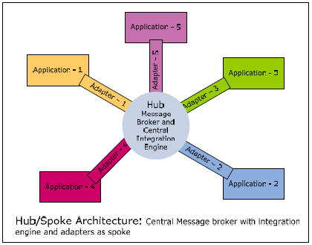

Examples of this architecture include IBM CrossWorlds, Vitria, and Web Methods.

BUS

Bus architecture uses a central messaging backbone (bus) for message propagation.
Applications would publish messages to bus using adapters. These messages would flow to subscribing applications using message bus. Subscribing applications will have adapters which would take message from bus and transform the message into a format required for the application. Key difference between hub/spoke and bus topology is that for the bus architecture, the integration engine that performs message transformation and routing is distributed in the application adapters and bus architecture requires an application adapter to run on the same platform as the original applications. Since adapters have integration engine and run on same platform on which source and target applications run, this scales much better and is complex to maintain compared to hub/spoke topology.

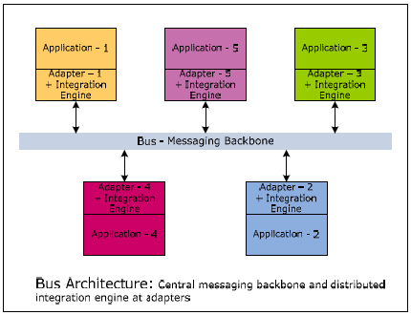

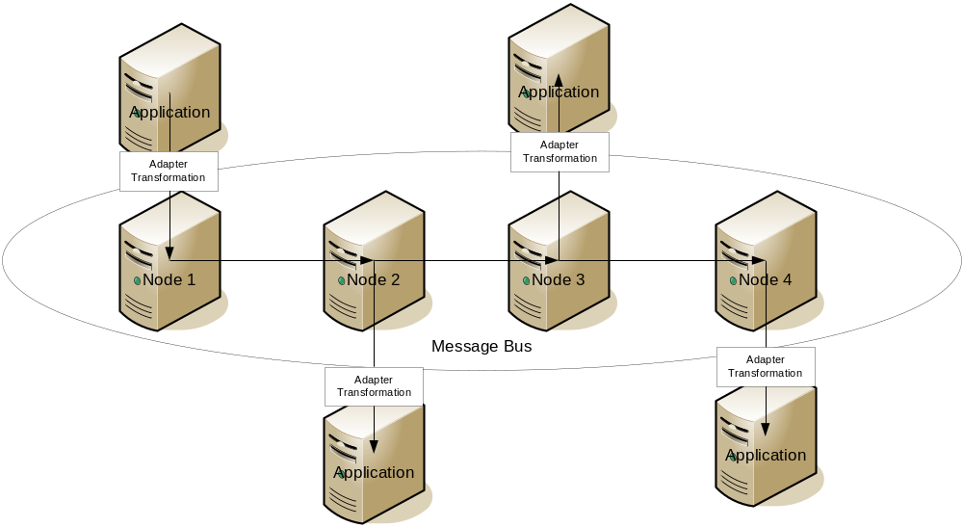

1) The big drawback that EAI architects point out with respect to hub and spoke model is the central point of failure. Since all the messages are going via a central hub server, HA of this server becomes extremely critical.
2) A webmethods based bus-type architecture with integration servers, brokers and territories/gateways can be easily drawn on a piece of a paper, but can add an additional layer of complexity (as Johnson mentioned). In this diagram, the bus essentialy is a pseudo-communication channel involving messaging between various brokers (using gateways and territories). Each Integration server (that can host multiple adapters) communicate with a single broker.
3) Some of the bus implementations (from other EAI vendors) that are out there depend on selective multicasting of messages over the network. This can potenitally cause network related issues and may require higher degree of maintenance.

4) Compared with the hub-and-spoke model, the bus model scales better and potentially offers better performance. However, implementation of the bus model is more complex and more difficult to administer as the environment grows.

5) The network was composed with multiple nodes and management of these nodes was more complex.

6) Routing between the nodes in the network was typically using a proprietary bus protocol and format so customers were restricted to a homogeneous integration broker technology across the whole bus.

7) Further routing on the bus was typically implemented by sending packets out to each of the nodes over Ethernet. This Ethernet routing mechanism used considerable bandwidth, caused a security risk on the bus as every node had access to the others messages in routing and eventually flooded the pipe between the applications.

8) Indeed the services offered by the bus were limited by its decentralization; even logging or monitoring information across the bus created considerable challenges because it typically involved either broadcasting logging packets to centralized logging machinery which further clogged bandwidth or browsing individual log files across multiple nodes.

Application connectivity
The bus/hub connects to applications through a set of adapters (also referred to as connectors). These are programs that know how to interact with an underlying business application. The adapter performs two-way communication, performing requests from the hub against the application, and notifying the hub when an event of interest occurs in the application (a new record inserted, a transaction completed, etc.). Adapters can be specific to an application (e. g., built against the application vendor's client libraries) or specific to a class of applications (e. g., can interact with any application through a standard communication protocol, such as SOAP or SMTP). The adapter could reside in the same process space as the bus/hub or execute in a remote location and interact with the hub/bus through industry standard protocols such as message queues, web services, or even use a proprietary protocol. In the Java world, standards such as JCA allow adapters to be created in a vendor-neutral manner.

Data format and transformation
To avoid every adapter having to convert data to/from every other applications' formats, EAI systems usually stipulate an application-independent (or common) data format. The EAI system usually provides a data transformation service as well to help convert between application-specific and common formats. This is done in two steps: the adapter converts information from the application's format to the bus's common format. Then, semantic transformations are applied on this (converting zip codes to city names, splitting/merging objects from one application into objects in the other applications, and so on).

Integration modules
An EAI system could be participating in multiple concurrent integration operations at any given time, each type of integration being processed by a different integration module. Integration modules subscribe to events of specific types and process notifications that they receive when these events occur. These modules could be implemented in different ways: on Java-based EAI systems, these could be web applications or EJBs or even POJOs that conform to the EAI system's specifications.

Support for transactions
When used for process integration, the EAI system also provides transactional consistency across applications by executing all integration operations across all applications in a single overarching distributed transaction (using two-phase commit protocols or compensating transactions).

Communication architectures
Currently, there are many variations of thought on what constitutes the best infrastructure, component model, and standards structure for Enterprise Application Integration. There seems to be consensus that four components are essential for a modern enterprise application integration architecture:
- A centralized broker that handles security, access, and communication. This can be accomplished through integration servers (like the School Interoperability Framework (SIF) Zone Integration Servers) or through similar software like the Enterprise service bus (ESB) model that acts as a SOAP-oriented services manager.
- An independent data model based on a standard data structure. It appears that XML and the use of XML style sheets has become the de facto and in some cases de jure standard.
- A connector, or agent model where each vendor, application, or interface can build a single component that can speak natively to that application and communicate with the centralized broker.
- A system model that defines the APIs, data flow and rules of engagement to the system such that components can be built to interface with it in a standardized way.
Enterprise Application Integration is related to middleware technologies such as message-oriented middleware (MOM), and data representation technologies such as XML. Other EAI technologies involve using web services as part of service-oriented architecture as a means of integration. Enterprise Application Integration tends to be data centric. In the near future, it will come to include content integration and business processes.

Advantages and Disadvantages
- Advantages
  - Real time information access among systems
  - Streamlines business processes and helps raise organizational efficiency
  - Maintains information integrity across multiple systems
  - Ease of development and maintenance
- Disadvantages
  - High initial development costs, especially for small and mid-sized businesses (SMBs)
  - Require a fair amount of up front business design, which many managers are not able to envision or not willing to invest in. Most EAI projects usually start off as point-to-point efforts, very soon becoming unmanageable as the number of applications increase

Opportunities missed by EAI
  - Business process improvement was only restricted to real time data exchange.
  - Flexibility required in business process required changes in business application and hence slowing down the entire process.
  - publish/subscribe implementation resulted in information overload.
  - information security was not inherently supported.
  - Ability to provide business context for any technical failure
  - EAI implementation mostly focussed on IT benefits hence missed business and IT alignment.

Enterprise Application Integration (EAI) Tools
- TIBCO
- MQSeries
- WebMethods
- Vitria
- iPlanet
- BizTalk
- WebLogic

Comparitive analysis of some Open Source product offerings in the integration space
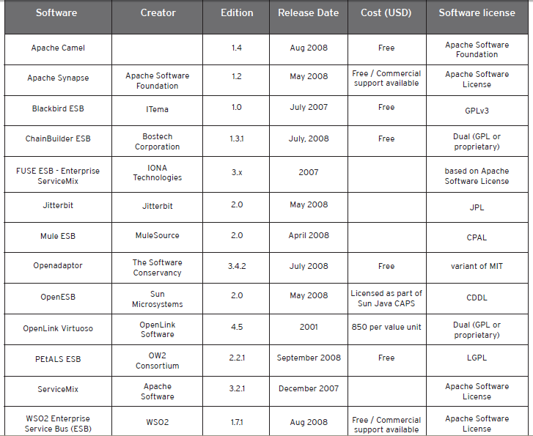

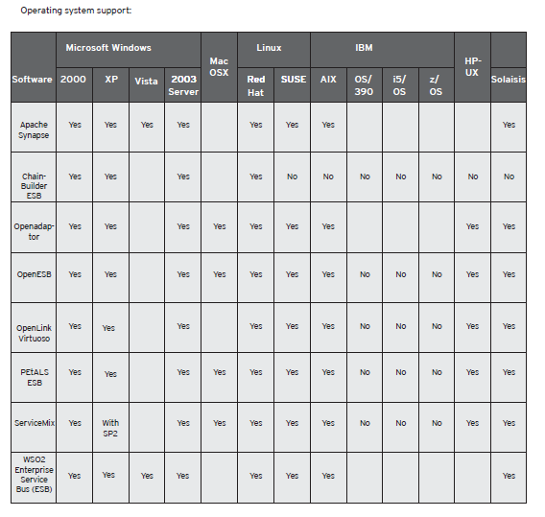

OpenEAI - The purpose of OpenEAI Project is to discover and document the controlling dynamics, principles, and practices of enterprise application integration and to present, implement, and promote those findings. The OpenEAI Project presents findings in the form of the OpenEAI methodology and OpenEAI software for implementing integrations. (LGPL)
OpenAdaptor - Openadaptor™ is a Java/XML-based software platform which allows for rapid business system integration with little or no custom programming. It is highly extensible and provides many ready-built interface components for JMS, LDAP, Mail, MQ Series, Oracle, Sybase and MSSQL Server as well as data exchange formats such as XML. New components are regularly added. (BSD based)
Mule - Mule is a simple yet robust and highly scalable component broker and services framework. Mule is a light-weight, event-driven component technology; it is highly scalable, using ideas from SEDA; designed around the ESB (Enterprise Service Bus). Components managed by mule can be Beans, EJBs, IoC3 compatible components, Servlets, POJOs, etc; Mule builds on existing best-of-breed lightweight containers and gives you the option to pick and choose which framework components you wish to use and connectors for JMS, HTTP, TCP, SMTP, POP3, FILE, XML-RPC and VM.
ServiceMix - Apache ServiceMix is an open source distributed Enterprise Service Bus (ESB) and SOA toolkit built from the ground up on the semantics and APIs of the Java Business Integration (JBI) specification JSR 208 and released under the Apache license. ServiceMix is lightweight and easily embeddable, has integrated Spring support and can be run at the edge of the network (inside a client or server), as a standalone ESB provider or as a service within another ESB. You can use ServiceMix in Java SE or a Java EE application server. ServiceMix uses ActiveMQ to provide remoting, clustering, reliability and distributed failover.
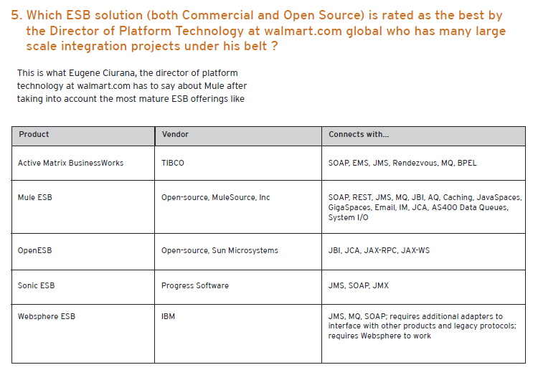
Mule ESB
Mule - Mule is a light-weight messaging framework. It is a highly distributable
object broker that can seamlessly handle interactions with other
applications using disparate technologies, transports and protocols.
Key Features
J2EE 1.4 Enterprise Service Bus (ESB) and Messaging broker
Pluggable connectivity such as Jms (1.0.2b and 1.1), vm (embedded), jdbc,
tcp, udp, multicast, http, servlet, smtp, pop3, file, xmpp.
Support for asynchronous, synchronous and request-response event processing over any transport.
Web Services using Axis or Glue.
Flexible deploment [Topologies] including Client/Server, Peer-to-Peer, ESB and Enterprise Service Network.
Declarative and Programmatic transaction support including XA support.
End-to-End support for routing, transport and transformation of events.
Spring framework Integration. Can be used as the ESB container and Mule can be easily embedded into Spring applications.
Highly scalable enterprise server using the SEDA processing model.
REST API to provide technology agnostic and language neutral web based access to Mule Events
Powerful event routing based on patterns in the popular EIP book.
Dynamic, declarative, content-based and rule-based routing options.
Non-Intrusive approach. Any object can be managed by the ESB container.
Powerful Application Integration framework
Fully extensible development model

EAI and ESB
EAI products are essentially the same as ESB products. The difference between them is ESB's addition of and emphasis on Web Services. Both EAI and ESB share the idea of a centralized point of control and try to reduce everything to a common denominator.

EAI and ESB- Wardens of Services?
EAI products are essentially the same as ESB products. The difference between them is ESB's addition of and emphasis on Web Services. Both EAI and ESB share the idea of a centralized point of control and try to reduce everything to a common denominator. The architecture of ESB and EAI middleware is almost the same.

EAI and SOA

 | Analysis | Define | Implement
EAI | - Analyze application portfolio.  - Analyze information exchange b/w application as per technical business flow. | - Identify integration points (database level, message level or API level).  - Define common message model to achieve source and target decoupling. | - Implementation logic for source to canonical message and canonical to target message format translation and validation.  - Implement MOM and broker platform to achieve loosely coupled integration  - Message reprocessing in case of broker failure.
SOA | - Identify “To Be” business process which could be monitored from both business and IT perspective.  - Identification of user roles and system usecases which form the basis for service rationalization. | - Define service contract.  - Define SLA’s and map them to business KPI’s  - Change focus from technical monitoring to business monitoring for defining the SLA’s. | - Implement services and business KPI’s  - Use business rules for creation of services based on condition based service interaction.  - User BPM for services which are based on process flow.

A message broker is an architectural pattern for message validation, message transformation and message routing.^{[1]} It mediates communication amongst applications, minimizing the mutual awareness that applications should have of each other in order to be able to exchange messages, effectively implementing decoupling.
The purpose of a broker is to take incoming messages from applications and perform some action on them. The following are examples of actions that might be taken in the broker:
- Route messages to one or more of many destinations
- Transform messages to an alternative representation
- Perform message aggregation, decomposing messages into multiple messages and sending them to their destination, then recomposing the responses into one message to return to the user
- Interact with an external repository to augment a message or store it
- Invoke Web services to retrieve data
- Respond to events or errors
- Provide content and topic-based message routing using the publish/subscribe model

http://www.infosys.com/offerings/it-services/packaged-application-services/white-papers/documents/eai-soa.pdf

Reference
http://www.mphasis.com/pdfs/OpenSourceEAI_SQATools.pdf
http://www.infosys.com/offerings/it-services/packaged-application-services/white-papers/documents/eai-soa.pdf

